**NOAA Ship THOMAS JEFFERSON Procedure Document**

Procedure:

**Reference Surface**

Creation Date:

8/28/2020

Revision Date:

Software used:

Caris HIPS&SIPS, HYPACK

Procedure Number:

**TBD**

Approved:

**TBD**

# Overview and Scope

Reference Surface

# Procedure Inputs and Outputs

## Inputs:

## Outputs:

# Procedure

**Reference Surface**

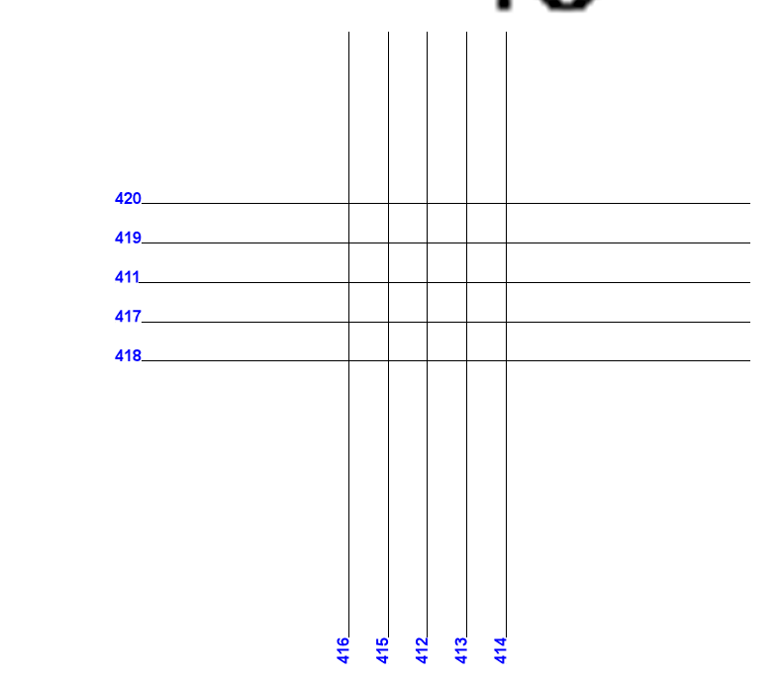

The reference surface should be run in an area that includes a flat area and a slope or feature. Conducting a reference surface over a feature with enough flat area is the best method. You need enough flat area to see any roll offset still present.

The lines should be run as seen above at normal survey speed. Direction does not matter but you want a good distribution to be able to see any pitch offsets that may still be present that weren’t resolved from the patch test.

After you run the reference surface, conduct a leadline comparison. Make sure you are within the reference surface area. Compare the leadline value with the value seen in the sonar.

Process your multibeam as you normally would. Within Caris open up a subset and examine your data. If you need to you can open up the calibration mode to resolve any residual offsets. Reference SOP "K:\Standard_Operating_Procedures\05_HSRR\20YY - Patch test.docx". Save these offsets when you exit subset and rerun the Georeference step within Caris 11 to correct your data. You need to save these values so you can create a corrected surface of what your system is going to run for the season for the reference surface comparison. For the rest of the field season update the values in the HVF for the launches or update them in SIS for the ship. DO not leave those values under Transducer 1 within the HVF for the field season. The values must be updated for acquisition. Saving them in the HVF is only so you can have a corrected reference surface.

Create a surfaces with the correct resolutions from the HSSD. Repeat steps for each vessel.

**Reference surface comparison**

Finalize the surfaces so that your comparison uses the 98% confidence level vs the 68% confidence level of a normal surface. Reference SOP "K:\Standard_Operating_Procedures\04_Deliverables\4 - Deliverables - DR, Surfaces, Mosaics, NODC\20YY - MBES_Final_Surface_Creation.docx"

The next step is to compare the Reference surfaces between the vessels. You can even compare between years if so desired. Compare the grids using the Compare Grids tool. Reference SOP "K:\Standard_Operating_Procedures\04_Deliverables\2 - Crossline-Junction_Comparison - DTON\20YY - CA_tools_ENC_SoundSet_comparison-DTON.docx"

Compare Grids tool will output a few jpgs of plots. The one you are looking for is the one shown below.

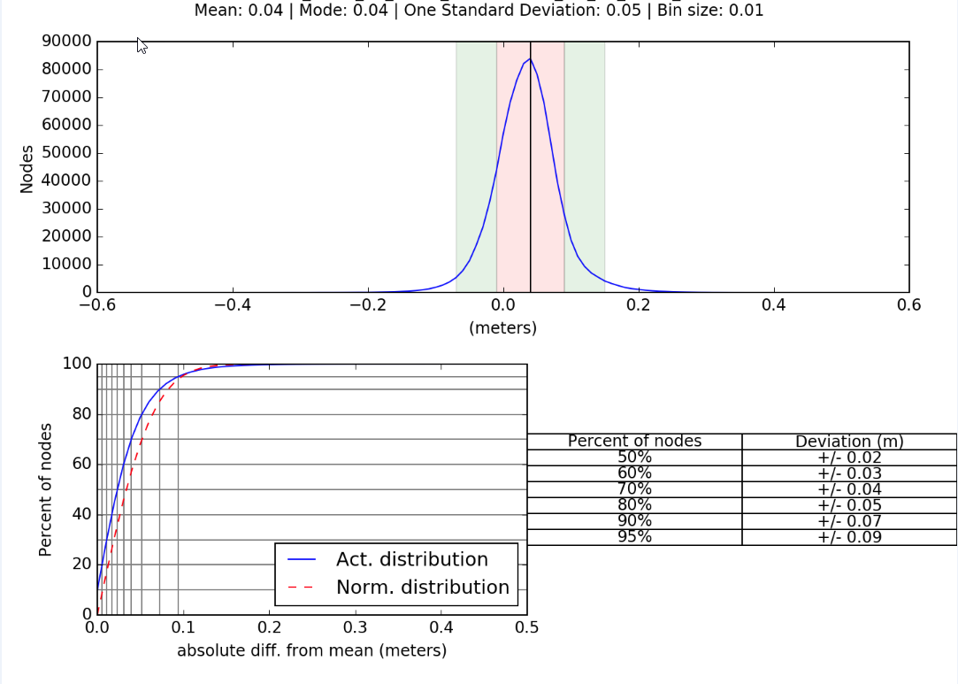

The one you must really pay attention to is the mean. The mean can tell whether or not you have a systematic bias between vessels. This mean is in the Z value. As long as the vessels are within 10cm you will be alright. A mean offset may be introduced by any number of things, sound speed for example. Keep in mind that with a smaller mean between vessels you will have more “wiggle” room in the error budget for TVU.

To get a more accurate picture of the mean value between vessels you may want to create a surface over just the flat area of the reference data and run it through the compare grids tool. Features and slopes insert a greater amount of deviation just depending on what node is selected when compare grids makes the difference surface.

# References

"K:\Standard_Operating_Procedures\05_HSRR\2020 - Patch test.docx"

"K:\Standard_Operating_Procedures\04_Deliverables\4 - Deliverables - DR, Surfaces, Mosaics, NODC\2020 - MBES_Final_Surface_Creation.docx"

"K:\Standard_Operating_Procedures\04_Deliverables\2 - Crossline-Junction_Comparison - DTON\2020 - CA_tools_ENC_SoundSet_comparison-DTON.docx"